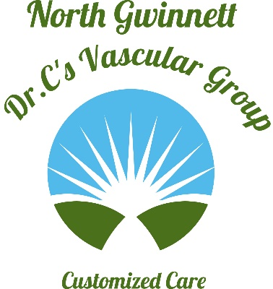
748 Old Norcross Rd, Ste 150
Lawrenceville GA 30046

Off: (470) 509 4200
Fax: (470) 509 4201
Udaya Chintalapudi, MD
Interventional Radiology
www.drcvascular.com
Email: info@drcvascular.com

Today’s Date: ____________ CHEST PORT Referral Form

Patient Name: _ _ _ _ _ _ _ _ _ _ _ _ _ _ _ _ _ _ _ _ _ _ _ _ _ Referring Phys. Name: _ _ _ _ _ _ _ _ _ _ _ _ _ _ _ _ _ Contact Phone Number: _ _ _ _ _ _ _ _ _ _ _ _ _ _ _ _ _ _ Referring Phys. Phone: _ _ _ _ _ _ _ _ _ _ _ _ _ _ _ _ _
Date of Birth: _ _ _ _ _ _ _ _ _ Referring Phys. Fax: _ _ _ _ _ _ _ _ _ _ _ _ _ _ _ _ _ _ _
Requesting for (date): _ _ _ _ _ _ _ _ _ _ _
Patient’s Address: _ _ __ _ _ _ __ _ _ _ _ _ _ _ _ _ _ _ _ _ _ _ _ _ _ _ _ _ _ _ _ _ _ _ _ _ _ _ _ _ _ _ _ _ _ _ _ _ _ _ _ _
Most Recent Lab Values: PT _____ (Date:_____________)
PTT: _______ (Date: _____________)
INR: _______ (Date: _____________ )
Platelets: ___________ (Date: ______________)

Is the patient on Blood Thinners: Yes / No. If yes, what kind?__________________

Nursing Home/Hospice Patient: Yes / No. Facility Name: _ _ _ _ _ _ _ _ _ _ _ _ _ _ _ _ _ _ _ _ _ _ _ _ _
Facility Phone: _ _ _ _ _ _ _ _ _ _ _ _ _ _ _ _ _ _ _ _ _ _ _ _

Procedure Requested: Port PLACEMENT / REMOVAL

Clinical Diagnosis: _ _ _ _ _ _ _ _ _ _ _ _ _ _ _ _ _ _ _ _ _ ICD 10: _ _ _ _ _ _ _ _ _
Type malignancy: _ _ _ _ _ _ _ _ _ _ _ _ _ _ _ _ _ _ _ _ _ ICD 10: _ _ _ _ _ _ _ _ _
Location of malignancy: _ _ _ _ _ _ _ _ _ _ _ _ _ _ _ _ _ ICD 10:_ _ _ _ _ _ _ _ _ _

(Preferred) Location of Port : Right Chest / Left Chest / Right Arm / Left Arm

X-ray Contrast Allergy: YES / NO Allergy Premedication Given: YES / NO

This form is completed by (Signature) : ___________________

Name : ____________________________________________

